**LAPORAN PRAKTIKUM**

**PEMROGRAMAN 3**



**Oleh:**

Muchamad Lutfi Maftuh

NIM. 19537141023

**PRODI TEKNOLOGI INFORMASI**

**JURUSAN PENDIDIKAN TEKNIK ELEKTRONIKA DAN INFORMATIKA**

**FAKULTAS TEKNIK**

**UNIVERSITAS NEGERI YOGYAKARTA**

**2020**

1. **Soal 10.2**
2. UML Diagram

|  |
| --- |
| BMI |
| - name: String  - age: int  - weight: double  - height: double  + KILOGRAMS_PER_POUND: double  + METERS_PER_INCH: double |
| + BMI(name: String, age: int, weight: double, feet: double, inches: double)  + BMI(name: String, age: int, weight: double, height: double)  + BMI(name: String, weight: double, height: double)+ getBMI(): double  + getStatus(): String  + getName(): String  + getAge(): int  + getWeight(): double  + getHeight(): double |

1. Run program



1. **Soal 10.3**
2. UML Diagram

|  |
| --- |
| MyInteger |
| value : int |
| MyInteger(value: int)  getValue(): int  isEven(): boolean  isOdd(): boolean  isPrime(): boolean  isEven(int myInt): boolean  isOdd(int myInt): boolean  isPrime(int myInt): boolean  isEven(MyInteger myInt): boolean  isOdd(MyInteger myInt): boolean  isPrime(MyInteger myInt): boolean  equals(int myInt): boolean  equals(MyInteger myInt): boolean  parseInt(char[] values): int  parseInt(String value): int |

1. Run program

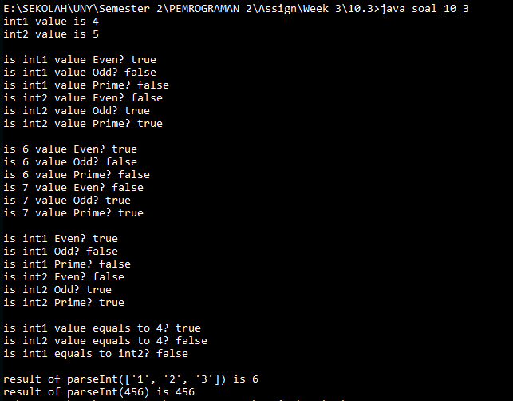

1. **Soal 10.7**
2. UML Diagram

|  |
| --- |
| Account |
| - id: int  - balance: double  - annualInterestRate: double  - dateCreated: Date |
| Account()  Account(id: int, balance: int)  getId(): int  getBalance(): double  getAnnualInterestRate(): double  getDateCreated(): Date  setId(id: int): void  setBalance(balance: double): void  setAnnualInterestRate(annualInterestRate: double): void  getMonthlyInterestRate(): double  getMonthlyInterest(): double  withdraw  deposit(total: double): void |

1. Run program

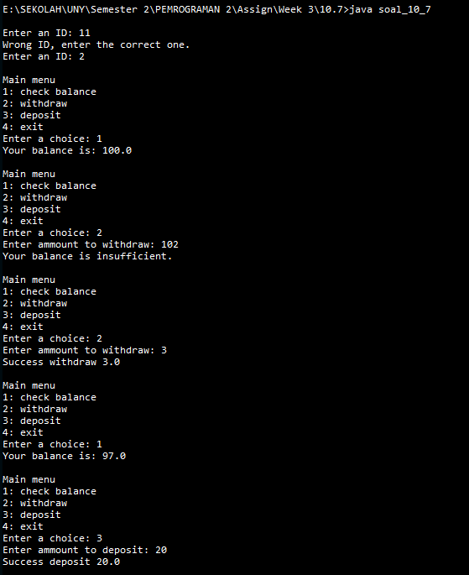

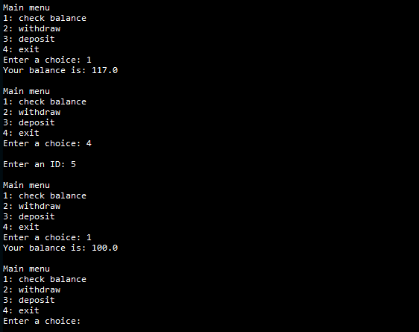

1. **Soal 10.9**
2. UML Diagram

|  |
| --- |
| Course |
| - courseName:  - numberOfStudents:  - students: |
| + Course(courseName: String)  + addStudent(nameStudent: String): void  + getStudents(): String[]  + getNumberOfStudents(): int  + getCourseName(): String  + dropStudent(String nameStudent): void  + clear(): void |

1. Run program

